PARKING RECEIPT |  |  | 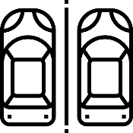
Address
[Contact Number]
 | Entry Time | 00/00/00 00:00 PM
 | Exit Time | 00/00/00 00:00 PM
 | Duration: 0d 1h 1m
 | Trans # | 0000000
 | Ticket # | 0000000
 | Total: $00.00
THANK YOU!
AND DRIVE SAFELY

